DUET 3 MAINBOARD 6HC

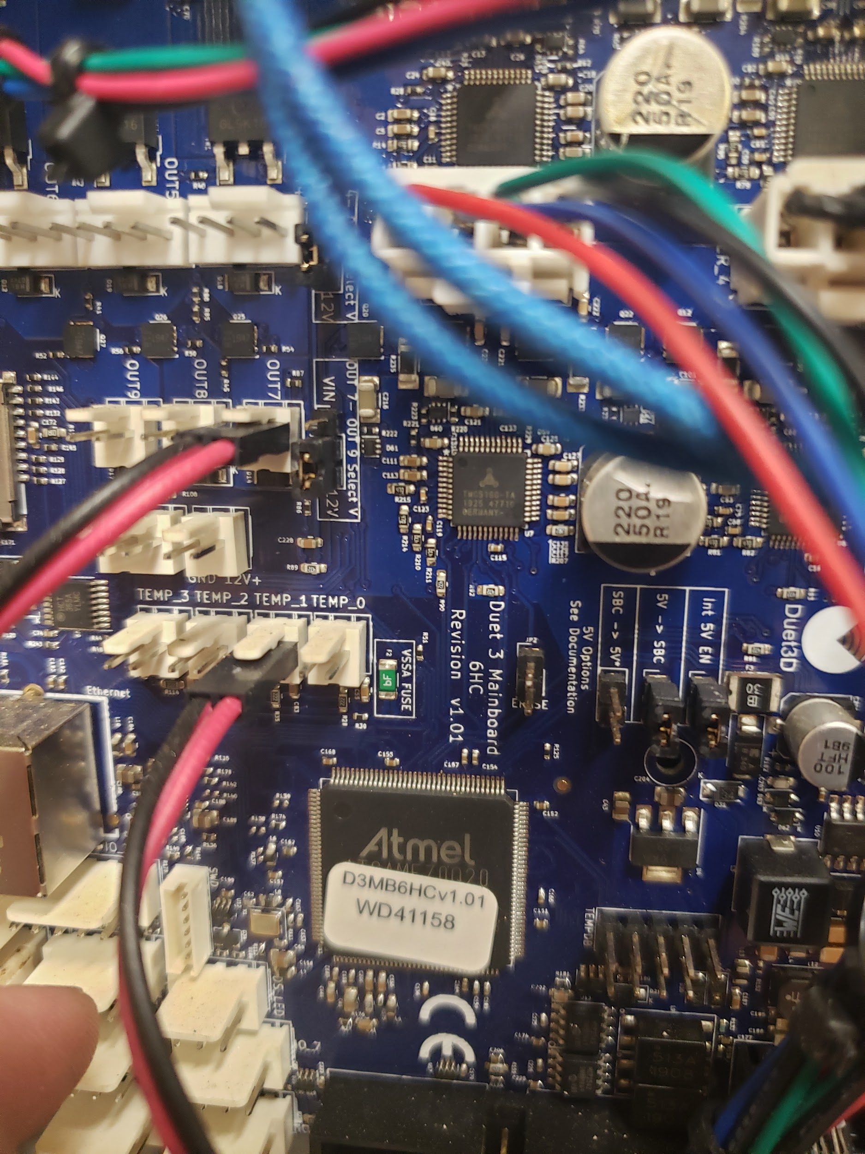

$229.80

The Duet 3 Mainboard 6HC featuring 6 High Capacity Stepper Drivers is Duet3D's latest generation controller board that builds on Duet3D's experience in developing the most flexible and expandable 3d printer control solutions. It is the core of the Duet 3 family which provides control for a wide range of machines including 3D printers, CNCs, laser cutters and more. The overall aim with the Duet 3 series is to allow for maximum flexibility of machine design through highly capable main boards, expansion boards, smart tool boards and custom expansion modules. The flexibility of configuration and advanced features are enabled by our innovative RepRapFirmware 3 running on the Duet 3 Mainboard and our customised DuetSoftwareFramework running on a single board computer.
- Powerful 32 Bit Processor (ARM Cortex M7 @300Mhz)
- Dedicated High speed bus to a single board computer (e.g. Raspberry Pi) for the user interface and plugins
- 6 High Capacity Trinamic 5160 stepper drivers running at up to 4.45A RMS, 6.3A peak with firmware control of the full feature set including up to 256 microstepping, StallGuard 2 and StealthChop2
- 2 CAN-FD buses that support the next generation of Duet3D expansion boards, smart tools and custom addons. The initial target is support for up to 8 x 3 channel expansion boards (another 24 stepper channels).
- 10 PWM outputs of varying current capacities support a high current heated bed, 3 extruders and 6 fans.
- 9 IO ports for endstops, probes, filament monitors and other sensors.
- 4 Thermistor/PT1000 inputs and support for 4 PT100/thermocouple inputs via the optional daughterboards.
- Connect via PC, tablet or smartphone on the same network to the onboard web interface.
- Set up your printer and update the firmware through the web interface.
- All common 3D printer geometries are supported
- Support for a wide range of Z probes including DC42’s IR Z probe and the Duet3D Smart Effector for delta printers.

Related Content

WorkHorse 3D Printer

Duet3D

Electronics

Stepper Motor Holding Torque

Electronics

Duet 3

Duet 3 Wiring Guide

Duet Wifi

RepRap Firmware

Docs

Stepper Motors

How To Calculate Stepper Motor RPM?

Stepper Motor Holding Torque

Unipolar vs Bipolar Stepper Motors

EndStops

0.9 vs 1.8 degrees Stepper Motors

WorkHorse-3D Printer Wiring

